Airline Customer Satisfaction

**Group Members:**

Y Nikhil Bhardwaj P Sai Varshith P J Subramanya Hande

PES1UG19CS586 PES1UG19CS320 PES1UG19CS316

**Abstract:**

The driving factor to any successful service organization is customer satisfaction and his feedback. Where er need to get insights. The dataset chosen was feedback collected from customers who are using their airlines. This implementation uses many approaches to classify satisfied customers and customers who are happy with certain features and who are not happy with certain features we have removed few attributes which are not useful for the analysis based on correlation analysis in preprocessing we have removed certain set of records like outliers to an extent We have used descriptive statistic tools in order to emphasize the data. Customer satisfaction was considered to be important in today’s competitive world. Customer satisfaction is important to build reputation and brand, to focus on areas of improvement, to beat competitors, reduce negative world of mouth and to maintain customer trust and support. The dataset given consists of the details of customers who have already flown with them. The main purpose of the dataset is to predict whether a future customer would be satisfied with the services provided

**I) INTRODUCTION:**

Today we have competition everywhere in every domain. We have many airlines to choose based on many factors. Airlines comes under service domain where the review, support and trust of the customer is driving key to the success.

The data given is about airline organization which contains the details of the customers used their airlines and their rating in different aspects.

In simple words, customer satisfaction is a measurement that determines how well a company’s products or services meet customer expectations. It’s one of the most important indicators of purchase intentions and customer loyalty. As such, it helps predict business growth and revenue.

We have many aspects to consider like timing, delay, service onboard entertainment, service quality, Food and drink, hospitality and so on. Service quality is one of the key objectives. to any public domain organizations because of the competition that is present nowadays in many instances service quality is assumed as the driving force to success. Customer satisfaction is the goal of the organization positive feedback from the customer can be taken as the goal of the successful organization

There are many analyses and studies on customer satisfaction. customer satisfaction has a strong impact and influence on the customer retention and business effectiveness in the firm.

In our analyses we have considered many aspects like the ticket class, Flight distance, seat comfort, online services, cleanliness, etc. We have collected feedback from the customers through rating. We have a range of 0-5 where 0 is poor and 5 is excellent we didn’t divide this range further and conducted analysis on this. It is important for a firm to know what the customers are thinking about organization it helps them in improving the services where ever it is needed so that they can be a business leader. Great customer satisfaction and number of loyal customers are strongly related. Metrics like share value, profit and sales show how the firm is performing currently. Customer satisfaction scores indicate how a firm will perform in future

Identifying and addressing dissatisfied customers is crucial to the success when we take care of them and show customers that they are given at most priority there are high chances of customer comeback and count. Customer satisfaction data allows us to emphasize which areas need to be improved for better health of the firm’s customer base. Many people are involved in the process

The paper has been organized as per the following sections:

II. Related Works and specifies the problem statement and dataset description

III. experimental results & Proposed solution and discusses the evaluation metrics for success

IV. Concludes the paper.

**II) Related works:**

1) LCA(Low Cost Airlines) providers always find ways to prove to their customers that it offers low price but not low quality. Many  studies  have  been  explored  on  the  subjects  of  the  service  quality,  cost, and customer satisfaction in the LCA around the world but still rarely any related research is in Vietnamese.

Chen  (2008)  has  appointed  that  customer  satisfaction  is  a  holistic  concept  that  it  represents  the  overall

emotional  response  after  consumption, and  it  can  range  from  the  level  of  dissatisfaction  to  satisfaction.  LCA  in

particular, customer satisfaction is a crucial factor of competitive advantage and helps to create the success for LCA

who  is  a  newly  participations  (Kim  &  Lee,  2011).

Besides,  customer  satisfaction  is  penchant  for  the  defence

to retain  customers  rather  than  for  the  offence  to  find  new

customers  in  a  competitive  environment  (Reichheld  & Sasser, 1990). Within theories about the elements of customer satisfaction.

It seems that price and service factors are core elements that influence strongly on customer satisfaction of a service company , In developing countries as Vietnam, LCAs are always attractive to customers through cheaper fares due to low  cost  strategies  and  diversified  revenue  sources.

Nevertheless, this article specifies  some  customers  believe  that  low  fares are synonymous with  poor service quality.  Hence their conclusion is that the main factor that was influencing the customer satisfaction in this article is the cost of the airlines

2) Many marketing studies (e.g., Overholt et al.,2007). revealed that there is certainly a positive link between high customer satisfaction from service quality and customers’ loyalty. Indeed, there are many benefits from high standards of service quality such as sustainable demand from satisfied consumers as well as a positive image at the market. J. Chen and C. Gursoy (2001) stated that consumer loyalty in tourism can be traced back to high standard of quality. J. Chen (1998), who had done many researches on international tourism decision making , revealed that the experience of high service quality often influence future decisions.

According to S. Shaw (2007), more domestic passengers are satisfied with the

quality of service, the more domestic passengers would  become loyalty to a particular airline brand. Therefore, Airline industry should work on improving their standards of service quality in order to gain reputation and increase the overall level of satisfaction. They planned to use stratified sampling and random sampling techniques with a more diverse group of tourists and try to increase the variety

of sample size provided time and budget allows. Moreover, they wanted to use small

group interviews with  in depth interview to investigate the reasons behind their

level of satisfaction for each particular factor of influence on tourist choice.

This article focuses mainly on the relationship between customer satisfaction and the loyalty and the airlines services.

3) Online system and websites are the new emerging channels by the companies  to  attract customers  around  the  globe. Customers can acquire all information from the company’s website. One of the papers aims  to  measure  the  customer  satisfaction  with  airline websites along with customer acceptance of the online system. This means to be a new research area for the  information  system  acceptance  researcher.  In one of the papers data was collected from 130  respondents who use airline websites for making their travel related decision.  This paper made use of a  survey approach to  gather  data  by  administering  the questionnaire  to  the  target  customers.  Statistical  tests  including  correlation , regression and exploratory factor analysis were applied to test on data resulting in support  of  all  hypotheses. The  result  indicates  that  all  independent  variables have  strong  significant  impact  on customer  satisfaction  with  online  system acceptance and with customer satisfaction. Hence the online services that is provided for the customers should be one of the main focus towards the customer satisfaction.

4) This study investigates the customer satisfaction of airline passengers and introduces perceived safety as a satisfaction driver, which has not yet been considered in the literature. Applying structural equation modelling to data collected from a sample of airline passengers reveals that perceived safety is one of the key drivers that can  explain  the  degree  of  overall  customer  satisfaction.  This relationship is, however , strongly moderated by the purposes for which airline passengers travel (i.e., either for business or pleasure). Perceived safety has a significantly greater impact on the overall customer satisfaction of people

who travel for pleasure than on that of business travellers, which implies that airlines should

more strongly emphasize safety features in advertising aimed at leisure travellers.

Unlike most other services, air travel also exposes passengers to physical risk. Even though

the airline industry claims that safety is its “number one priority”  (International  Air Transport  Association  2010b) and accident rates have fallen over the past 20 years (Inter-

national Civil Aviation Organization 2009), the occurrence of  accidents cannot be eliminated completely and passengers are aware of this fact. They even perceive air travel as

more risky than is justified from an objective point of view because individuals generally overpasses the risk associated with low-probability events (Viscusi 1985).

**III) Solution Approach:**

1. Dataset Description:

This dataset has 23 attributes and about 1.3 lakh records of these attributes , There are 5 qualitative attributes , and the attribute satisfaction is the targeted attribute

1. Pre-processing:

Satisfaction , gender , customer type , The values in these attributes were encoded as 0 & 1 and for class attribute the values were encoded as 0,1&2 , These four attributes were modified for numerical co-relation analysis

1. Based on correlation analysis and PCA we found 2 redundant attributes namely : Gate location and Type of travel and hence these attributes were removed

**IV) Visualization:**

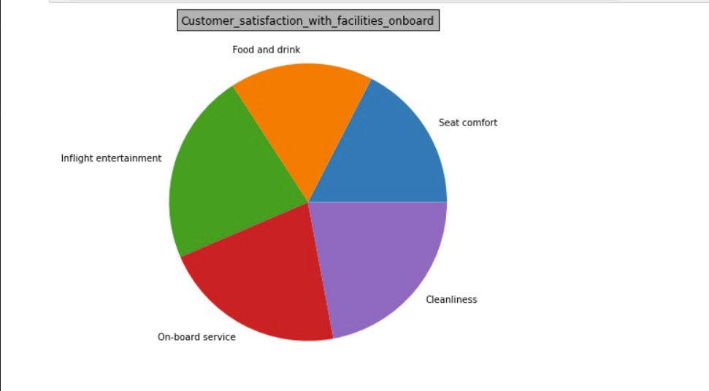

1. We have encoded the class types into numeric data i.e. 0 is eco, 1 is business and 2 is Eco plus so we can understand that as the range of price increases the services are more so customers are satisfied , We can say that as the type of class increases the customers are more satisfied

1. we have combined Online support, Ease of Online booking, Online boarding attributes into a single attribute in the virtual data frame to get inferences there are many people who are dissatisfied also giving a better rating so we can say customers are less keen on online services
2. In the pie chart analysis, we grouped satisfied and dissatisfied customers and in the picture is of satisfied customers We can say that customers are less keen towards Food and drink and more interested towards onboardservices

4) We even did outlier analysis to an extent using boxplot:

1. Table

   Description automatically generatedWe grouped customers into different categories to get insights:

1. In Business Class, there is high satisfaction between the male and female loyal customers In Eco Class, the female loyal customers have higher satisfaction as compared to male loyal customers

Among the three different classes, Business class has the highest satisfaction

8) Loyal customers have higher satisfaction over disloyal customers

9) Female customers is seen to have higher satisfaction ascompared to male customers

Many people have used normalization in preprocessing part we have made use of correlation and heat map to remove attributes which are irrelevant to target attribute we have encoded categorical variable. Most of the research papers have seen how customer satisfaction varies against any particular attribute such as quality of service, ease of online services and customer loyalty whereas we grouped related attributes and conducted analysis.

**Conclusion:**

Onboard Service is the most important flight service attribute and Online Boarding is the most important pre-flight service attribute for passengers.

The flight arrival delay of some less time is positively perceived by passengers but Departure/Arrival Time Convenience is considered a less important attribute by passengers.

The most satisfied group of customers are mostly female business passenger's traveling in the business class. On the other hand, the satisfaction can be significantly improved in a large group of business customers traveling in eco class.

References :

1. https://www.academia.edu/download/55007446/Article_313.pdf
2. <https://www.sciencedirect.com/science/article/pii/S0969699718304873>
3. https://www.inderscienceonline.com/doi/abs/10.1504/IJBIR.2017.082829
4. <https://www.tandfonline.com/doi/abs/10.2753/MTP1069-6679190407>
5. <https://www.kaggle.com/sjleshrac/airlines-customer-satisfaction>